**2020-2021 WSU Capstone Project**

**Encoder Display Interface – Requirements and Notes**

**V 1.1**

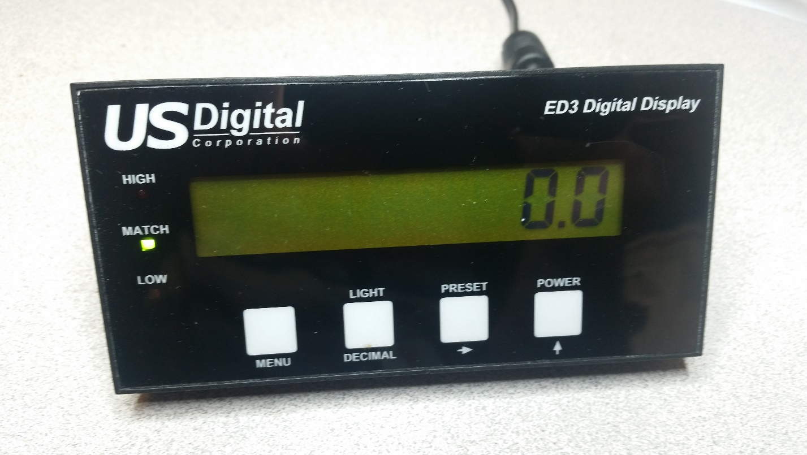

**Background**

The goal of this project is to design new electronic hardware to upgrade our existing ED3 Digital Display device. Our existing product (pictured above) displays limited information on its 8-character, 7-segment display and it is difficult for a user to configure using the 4-button interface. It is also limited to one quadrature or PWM encoder input. For reference, the data sheet for this product can be found at: <https://www.usdigital.com/products/accessories/digital-displays/ED3> .

The newly designed hardware will allow device information to be displayed from all the US Digital encoder products. It will display information for up to two simultaneous encoder inputs. It will support quadrature, Step/Direction, PWM, RS232, RS485, SEI and analog encoder inputs. The display unit will be configured using a PC GUI application and parameters will be communicated over a USB interface. The display will also be enhanced to a multi-line alpha-numeric type.

**Hardware Requirements**

1. It is highly desired that the new electronic hardware fit into the existing ED3 product housing. Here are the dimensions of the current housing:

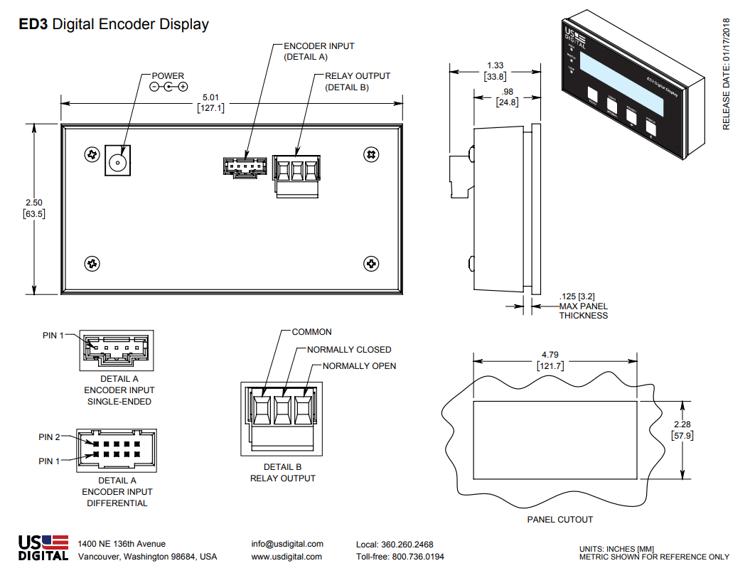

The connectors in the diagram above are for our incremental and PWM encoder products. We will be adding additional connectors for our currently unsupported products.

1. The display unit will have at least a two-line alpha-numeric LCD display with backlight. This can be an LCD module or a discrete LCD. A module, using an integrated control unit, may be easier to develop since it has the display driver built in.
2. Four momentary switches will allow for user control during standalone operation. Switch PN: PTS645SL70-2LFS
3. The display unit will operate from USB power when connected to a PC or operate standalone from an external 12V DC power source. Note: some of the encoders will require that the 12V source be connected. The external power connection will use a 2.1mm diameter center post power jack. This will be compatible with our existing 12V wall power modules. Suggested PN: PJ-044A
4. A USB connection will provide power for the display and a serial port connection to a PC. The PC will send operational parameters and user inputs to the display unit; it will also be able to read data from the display unit. (Note: we have used FTDI devices for USB interfaces in some of our other products; FTDI website: <https://www.ftdichip.com> . Suggested USB connector PNs: UJ2-AV-2-SMT-TR or 1734517-1
5. Use a Microchip 16-bit PIC microcontroller. It has useful built-in features such as:

* 12-bit A/D
* Multiple UART ports
* Multiple SPI ports
* Quadrature decoder with index (need at least a 16-bit quadrature counter)
* Possibly a USB port (slave mode)
* Probably this project will require >= 128 KB program memory
* Internal non-volatile memory for user parameter storage

At a minimum, enough microcontroller firmware will be written to demonstrate the functionality of the electronic hardware. Write all firmware in C language.

1. The display unit will have at least 256 bytes of non-volatile memory for storing user configuration information. This memory could be contained within the microcontroller.
2. The following encoder inputs will be supported:

* Capability for two Differential and two single-ended quadrature inputs with index. Connector: 5-pin locking; PN: 5-103639-4 (single ended); connector: 10-pin locking; PN: 15477510 (differential).
* Single-ended step/direction inputs. Connector: 5-pin locking; PN: 5-103639-4
* 12-bit PWM with 250 Hz to 2kHz period. Connector: 5-pin locking; PN: 5-103639-4
* RS232/RS485 (bidirectional communication) Shared Connector: 5-pin M12; PN: 284740. Only available when using external 12V supply.
* SEI bus interface (see SEI definition at: <https://www.usdigital.com/support/resources/reference/user-guides/sei-serial-encoder-interface-bus> ) Connector: RJ11 Modular Jack; PN: MTJ-663X1. Only available when using external 12V supply.
* 12-bit analog input, 0 – 5V. Connector: 5-pin locking; PN: 5-103639-4

1. A switching type power supply voltage regulator will be used to generate the needed voltages on board. 5V will be needed to power some of the attached encoder units. The 5V supply should be capable of supplying 150 mA of current to external 5V encoders.
2. An open-drain output FET transistor will be provided to switch external circuitry. It will be capable of switching 1 A of current (max) and 30V max Vds. Driven directly from microcontroller.
3. All components will be surface mount with a few exceptions (Possibly the LCD display, switches, USB connector and RJ11 Modular Jack)
4. All components will be readily available from DigiKey ([www.digikey.com](http://www.digikey.com)) or Mouser ([www.mouser.com](http://www.mouser.com)). All components must be compliant with RoHS and REACH standards; we will help with this.
5. PCB design will be a two-sided board, FR4 material, that is 0.063” thick. Suggest using Altium CircuitMaker Schematic/PCB layout tool (see design tools section below).

**System Block Diagram**

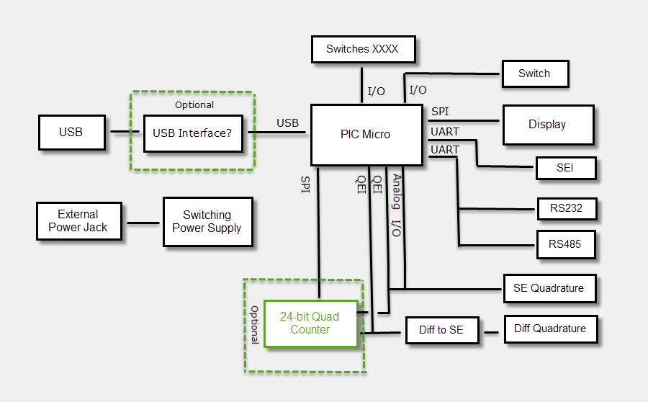

**Connector Pinouts**

1. **Single-ended (5-pin) and differential (10-pin) encoder inputs.**

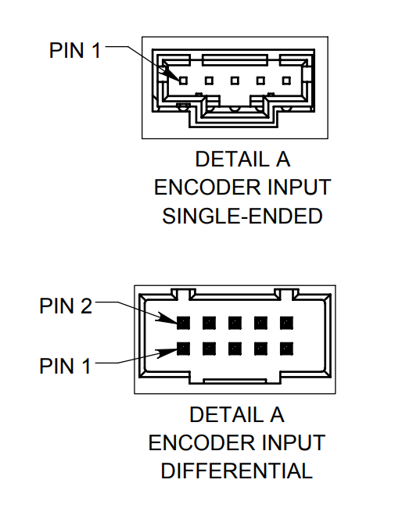

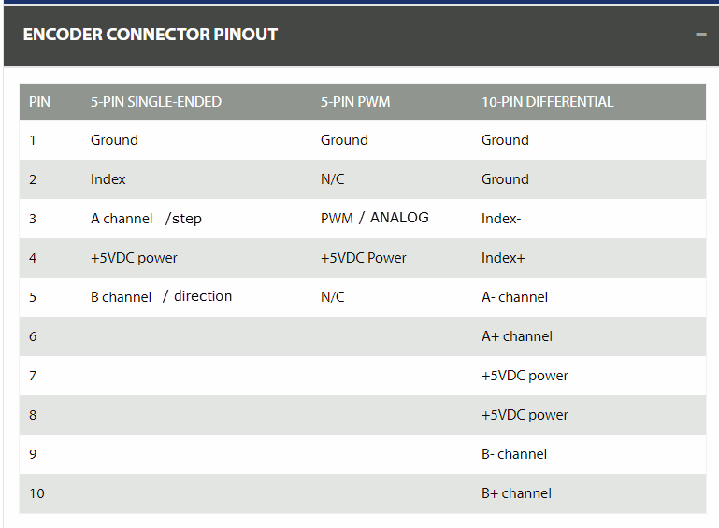

The single-ended quadrature encoder, step/direction encoder, PWM encoder and Analog encoder inputs will share the same 5-pin connector. The 10-pin connector will only be used for the differential encoder input. We will limit to two of these encoder connections that can either be stuffed with a 5-pin connector or a 10-pin connector.

1. **RS232/RS485**

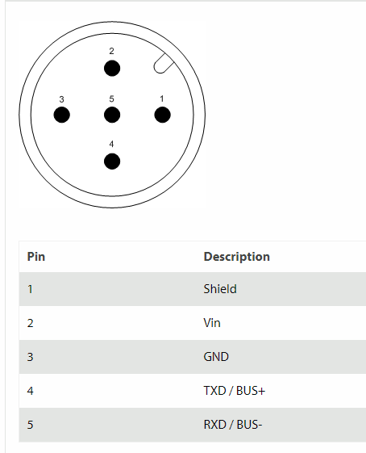

The RS232 and RS485 interface will share the same connector. Vin will be 12V

1. **SEI**

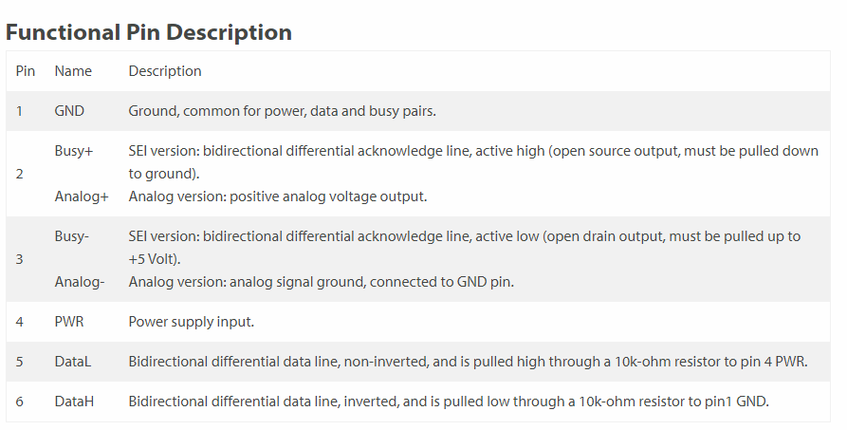

PWR will be 12V

**Suggested Design Tools and Web Sites**

1. Free schematic and PCB Layout Tool that generates files that are compatible with our currently used Altium Designer PCB layout tool: Altium CircuitMaker <https://circuitmaker.com/>
2. Analog Simulation Tool: LTSpice [https://www.analog.com/en/design-center/design-tools-and-calculators/ltspice-simulator.html#](https://www.analog.com/en/design-center/design-tools-and-calculators/ltspice-simulator.html) . Useful for switching voltage regulator design.
3. Electronic component part Sources: [www.DigiKey.com](http://www.DigiKey.com) , [www.Mouser.com](http://www.Mouser.com)
4. Some standard component schematic symbols and PCB footprints: <https://www.ultralibrarian.com/> . Or, you can make the symbols from withing CircuitMaker.
5. You will need an in-circuit firmware design tool. Free software is available from Microchip. We can supply a Microchip PICkit-3 programmer dongle if needed.

**Project Challenges**

1. On-board switching power supply regulator design. LTSpice analog simulation tool may assist in this design.
2. Learning PCB layout techniques. I can help with this.
3. Switching between RS485 and RS232 communication on one shared connector.
4. Component selections. Also, choosing the best PIC microcontroller for the project.
5. Making all if the electronic circuitry fit on the desired PCB size. We may have to increase the PCB size if all the components will not fit, TBD

**Other**

1. Email a copy of your status reports to [Allen.Harstine@usdigital.com](mailto:Allen.Harstine@usdigital.com)
2. Please contact me (Allen Harstine) if you have any problems with the design requirements or other questions. Email: [Allen.Harstine@usdigital.com](mailto:Allen.Harstine@usdigital.com) .
3. We should review each milestone step below as you complete these steps:

* Product requirements review
* Product block diagram or project plan review
* Parts selection review
* Schematic review
* Test firmware review
* PCB pre-layout review
* PCB post-layout review

1. USD can help with circuit board fabrication (soldering). Some of the packages will require reflow soldering since the conductors my be on the bottom of the component package.
2. US Digital product website: [www.usdigital.com](http://www.usdigital.com)